

RESTful API Task

**Student Name:   Pham Hong Phuc**

**Student ID:  001284212**

In this final section of weekly reports, RESTful APIs tasks are the last crucial part that is needed to perform the MEVN stack web development. APIs are actual inner concealed raw data that got kept inside a website structure; to be precise, they are used to convert data to textual on the widgets and metadata on the site.

To begin with, such tasks to initiate is doing 3 straightforward command lines on the terminal that integrated with root folder:

- ‘npm init -y’ – define the path with a primary .js file to initialize the webpage

- ‘npm install express body-parser mongoose’ to download certain necessary modules to execute the function within it

The folder is fractionated in 3 sub-folders:

- ‘server’ – an initial file that is very important to launch all others files so it connects to the database, then start the website in real-time.

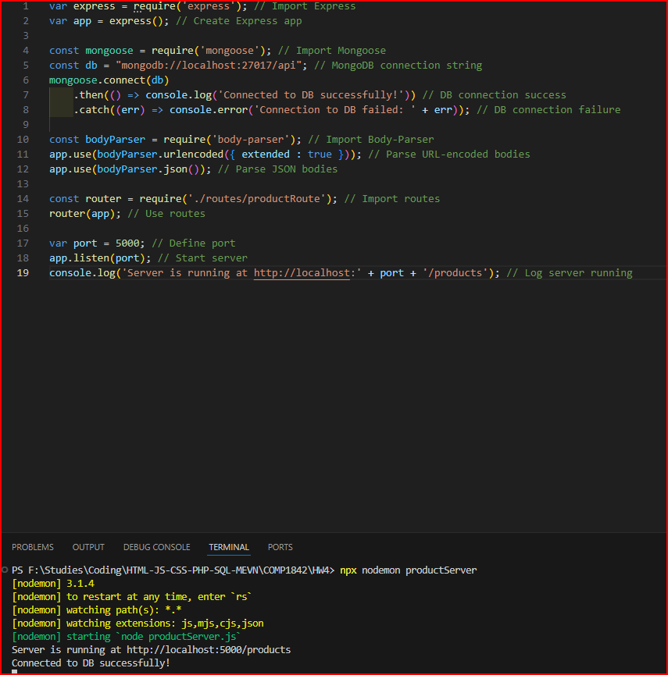

- ‘model’ – a designated file that form the basic structure of a simulated class and the original source to make an API data.

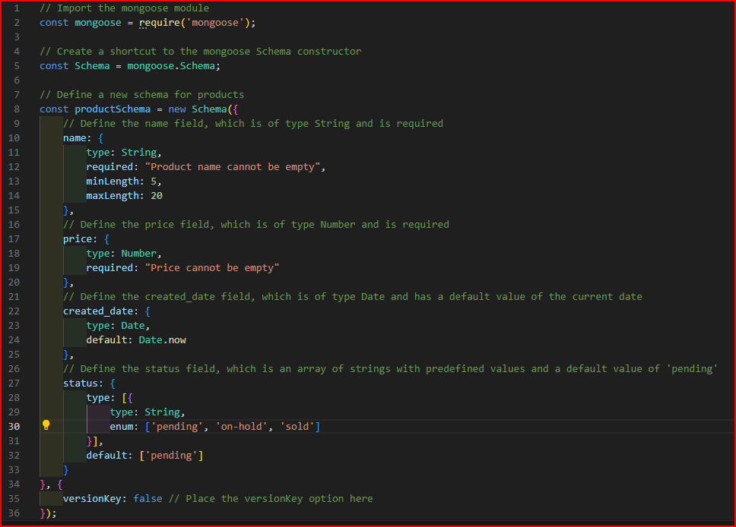

- ‘controller’ – a functional file that is hard coded with NoSQL basic CRUD features, its perquisite is the ‘model’ file.

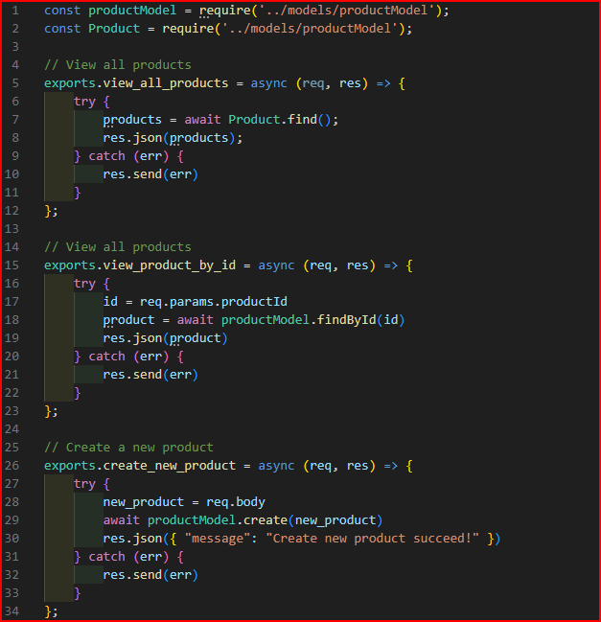

And:

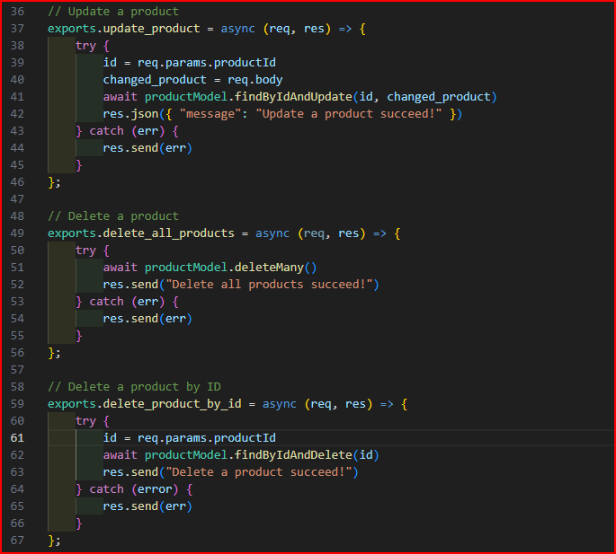

- ‘route’- a bridge-like file that is connect and attach functions from ‘controller’ so as the API can hook with the ‘server’ file.

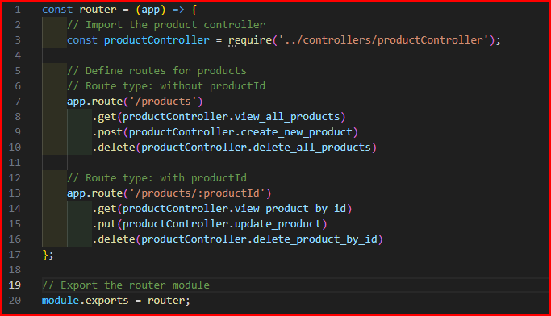

Now, we test with the Postman to fetch the APIs and do the fundamentals CRUD objectives.

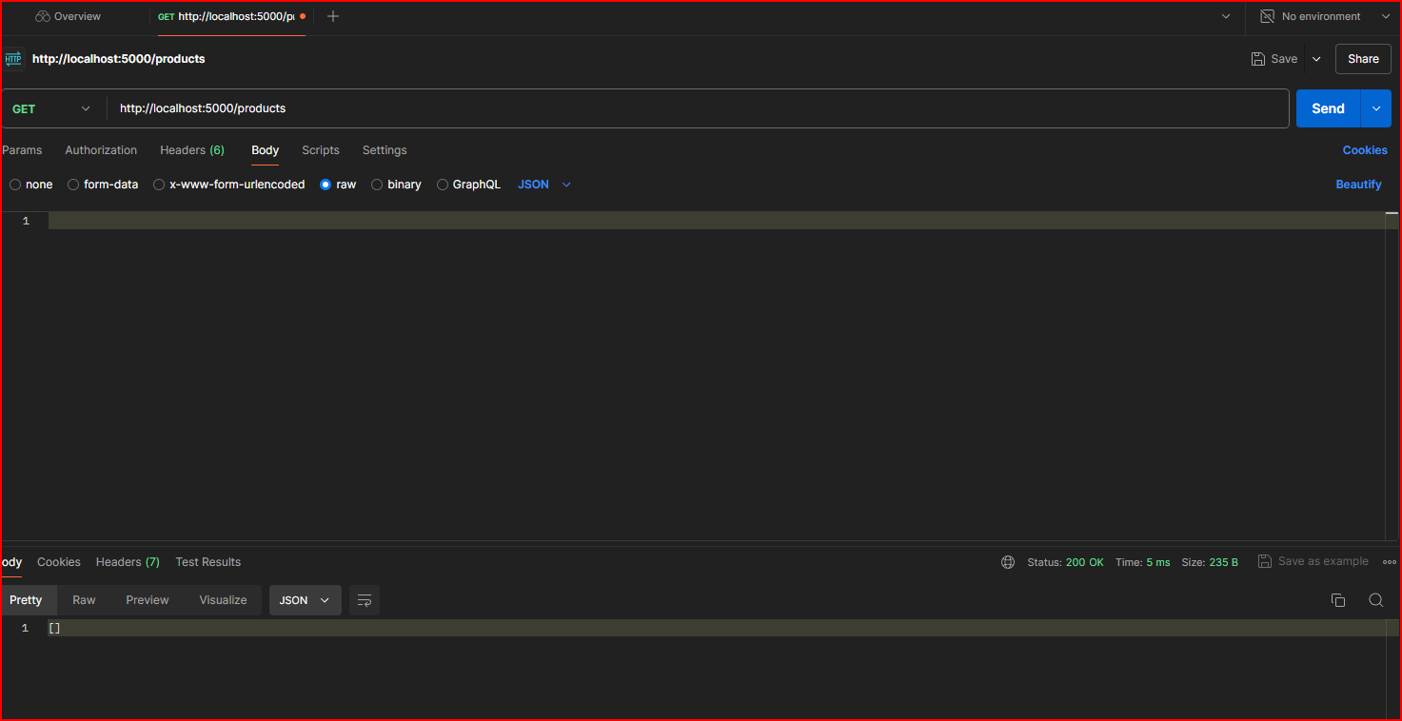It seems we GET the data correctly and its said 200, which means the request was successful.

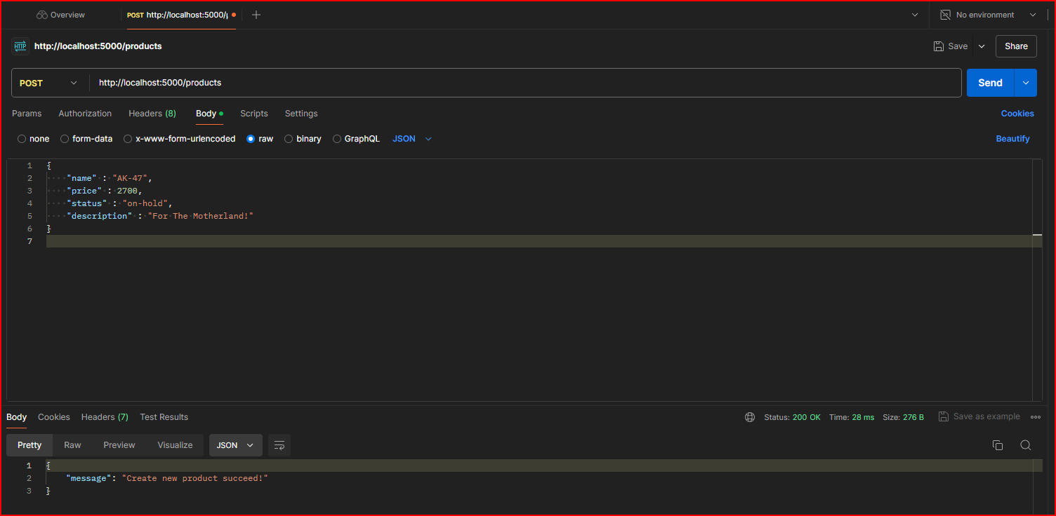  
POST is the first one to execute.

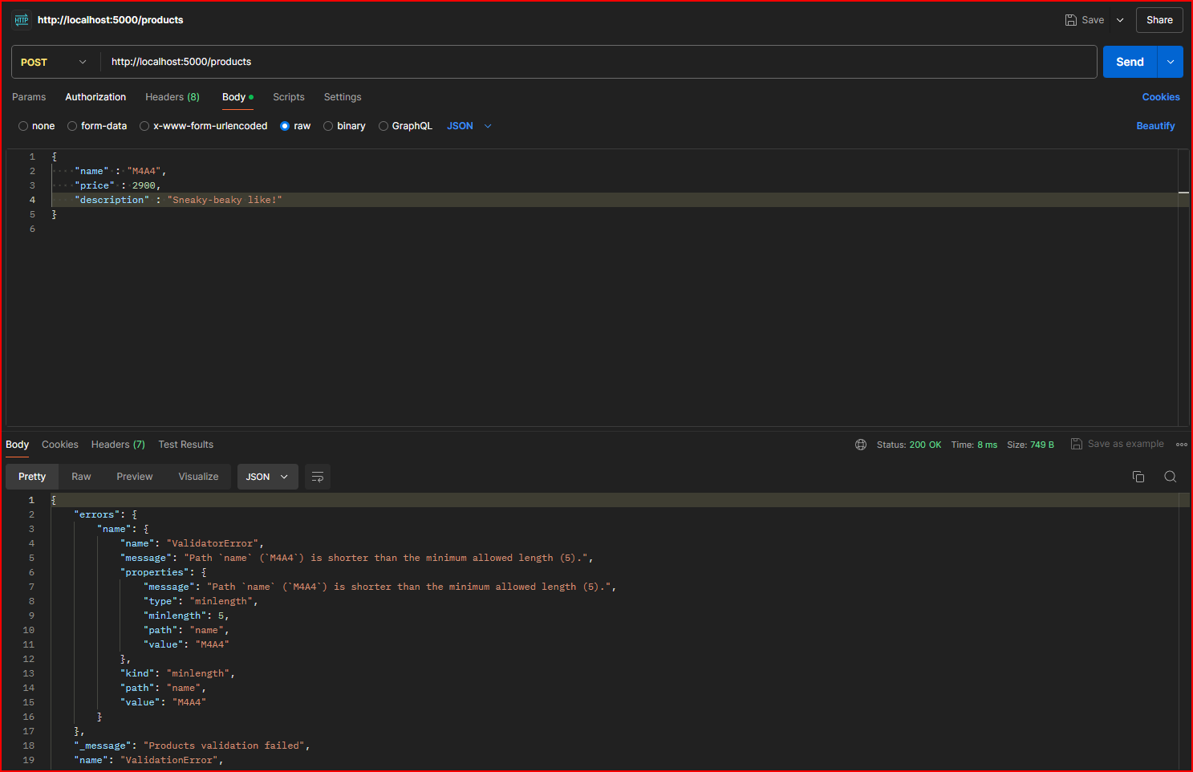

The result.

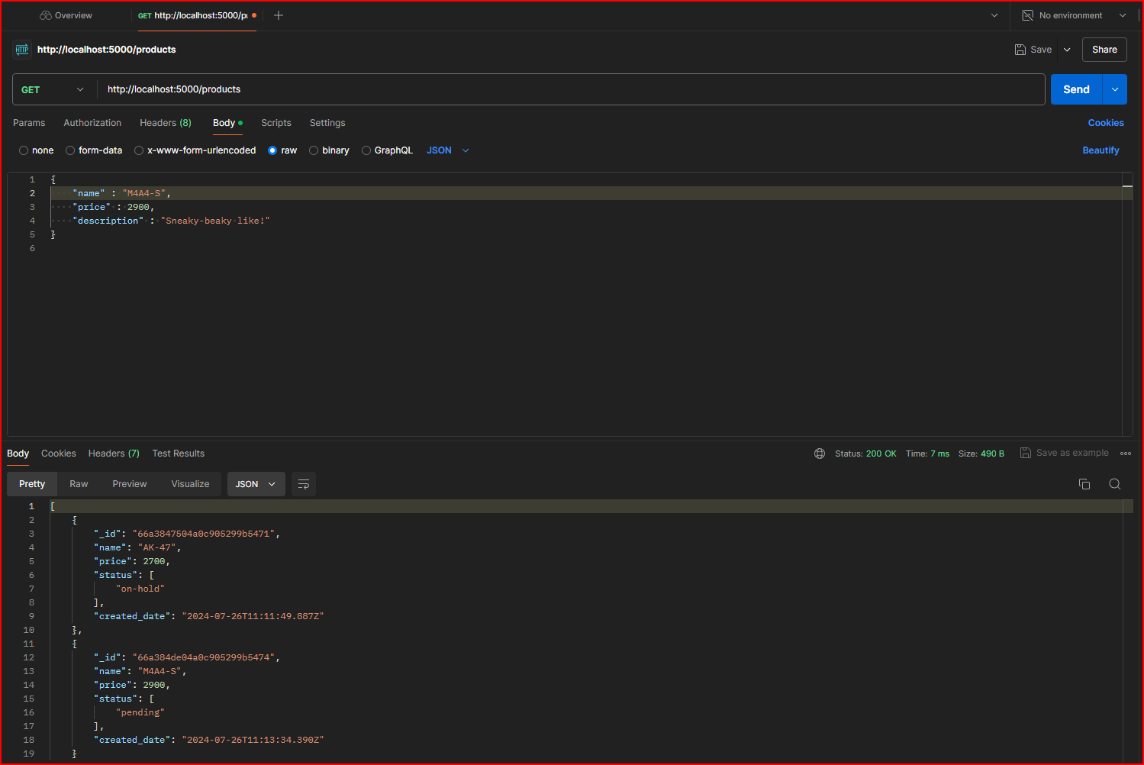

Second Attempt.

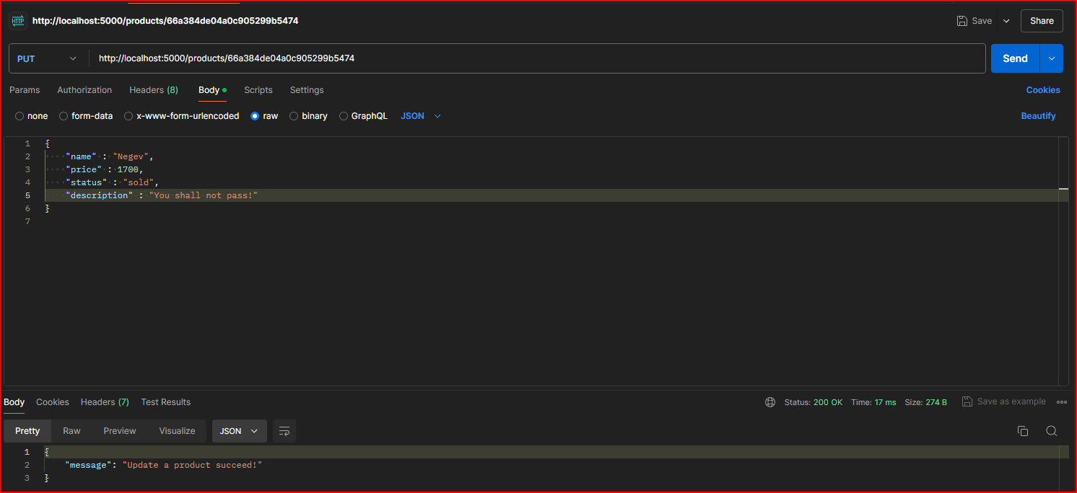

PUT to adjust the attributes data.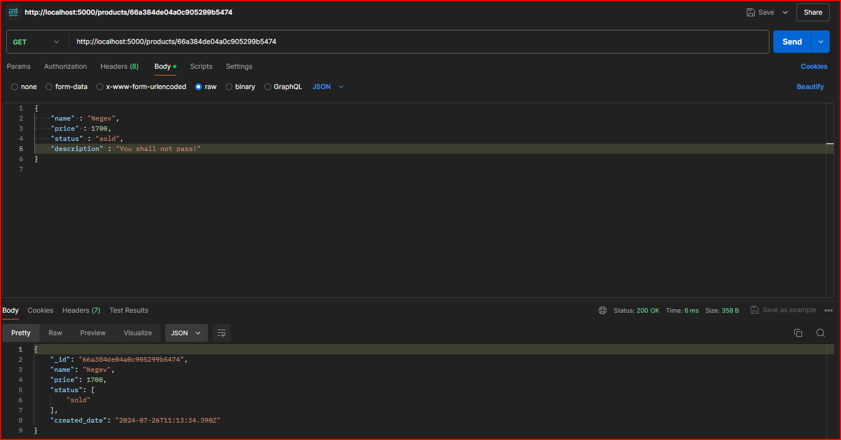

Then we achieved it.

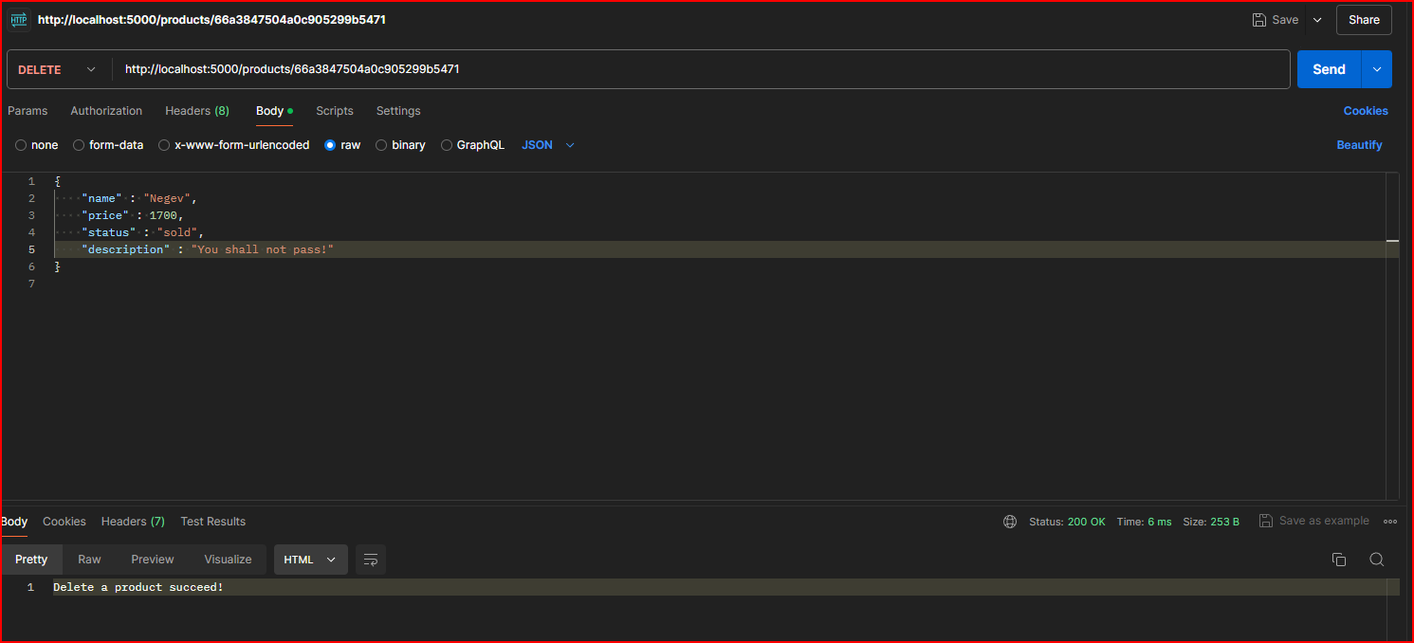

DELETE is also put in action but this one is in single search from the delete with ID function.

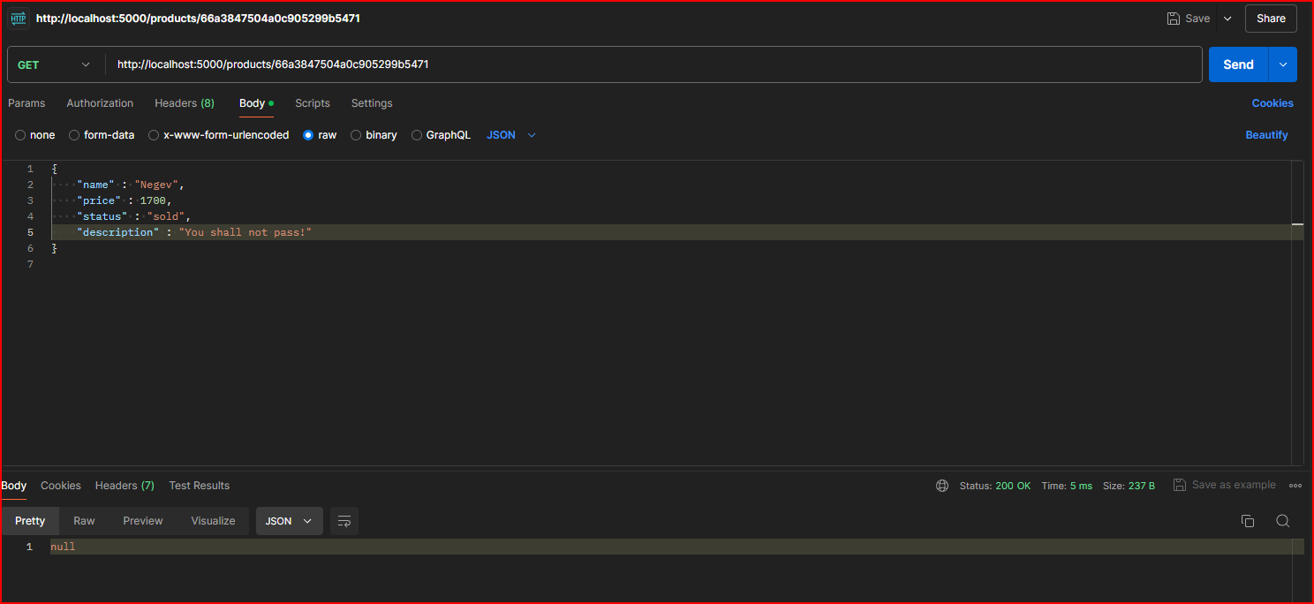

We got it with null – also the GET with ID was also shown from this above image.

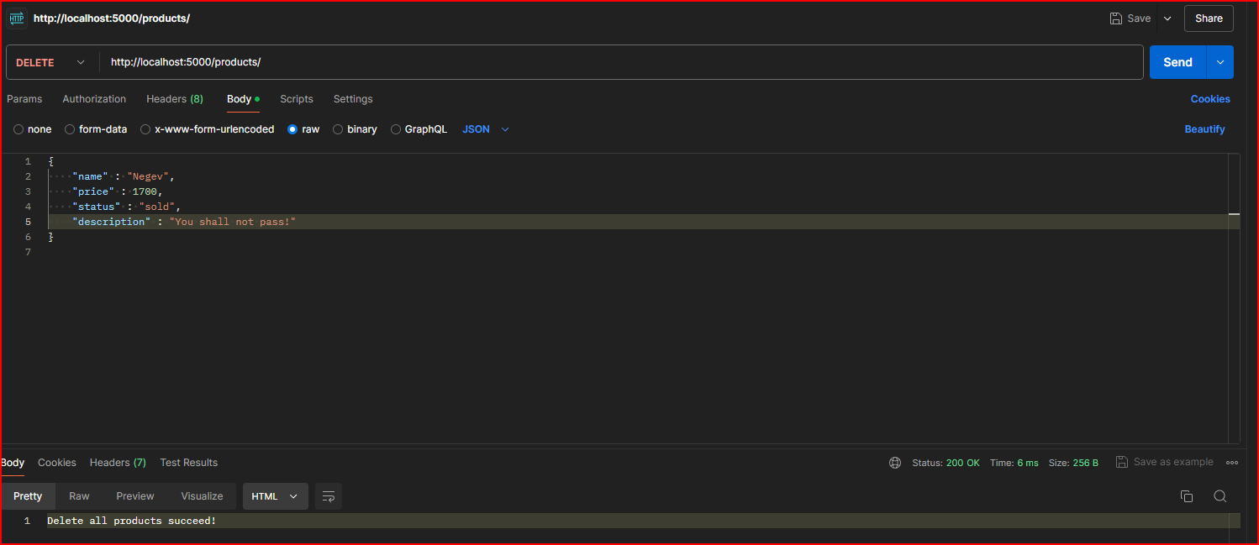

DELETE all the data is also works out with the console log.

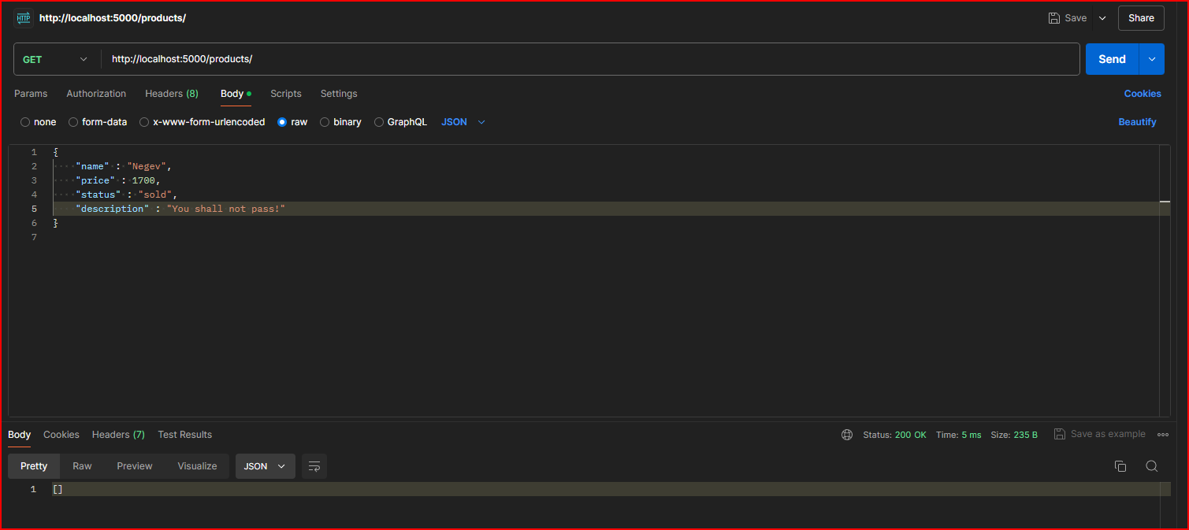

The consequential with the empty array is means the DELETE works.

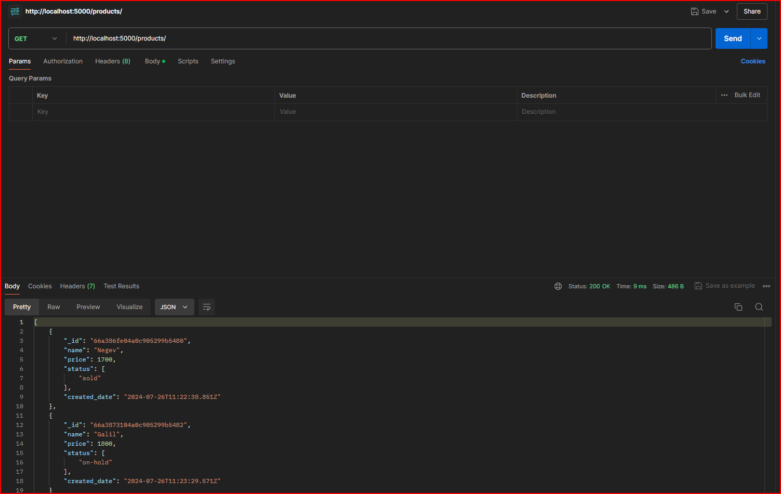

Another look to match with the raw data shown on the webpage, simultaneously

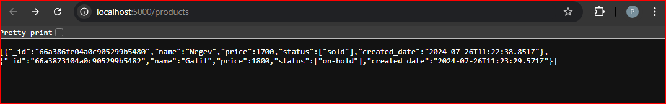

The APIs do their jobs well-done to appear on the website.